Discussions Wk6D

Part I
Explain the relationship among disk platters, tracks, sectors, and clusters.

Solution:
Hard disks have Metal or glass disks called platters, which are divided into sectors. sectors are divisions of concentric circles called tracks. Groups of sectors are called clusters.

Part II

Given the following sequence of events (Interrupt requests IRQi), show which services routines the CPU is executing for times 0 to 100 ms. Consider that each IRQi- Interrupt service routine takes 15 ms to complete.
Time Action
0 ms Start of main program
10 ms IRQ3 Interrupt request 3 is coming
20 ms IRQ2 Interrupt request 2 is coming
45 ms IRQ1 Interrupt request 1 is coming
60 ms IRQ0 Interrupt request 0 is coming

IRQ n has the lowest priority; IRQ 0 has the highest priority
Obs:
If IRQi is coming in the period of execution of IRQj and j has higher priority, then IRQi is postponed until IRQj is finished.
If IRQi is coming in the period of execution of IRQj and i has higher priority, then IRQi is started and IRQj is temporally suspended until IRQi is finished.

Indication:
Please see here a similar example considering each IRQ service routines takes 20 ms to complete.

Given the following sequence of events (Interrupt requests IRQi), show which services routines the CPU is executing for times 0 to 100 ms. Consider that each IRQi- Interrupt service routine takes 20 ms to complete.
Time Action
0 ms Start of main program
10 ms IRQ3 Interrupt request 3 is coming
20 ms IRQ2 Interrupt request 2 is coming
45 ms IRQ1 Interrupt request 1 is coming
60 ms IRQ0 Interrupt request 0 is coming

IRQ n has the lowest priority; IRQ 0 has the highest priority
Obs:
If IRQi is coming in the period of execution of IRQj and j has higher priority, then IRQi is postponed until IRQj is finished.
If IRQi is coming in the period of execution of IRQj and i has higher priority, then IRQi is started and IRQj is temporally suspended until IRQi is finished.

The solution for 20 ms is:

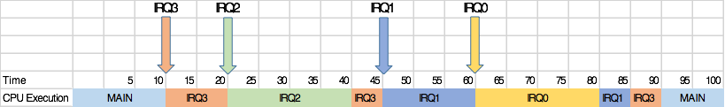

More details is presented in the following figure:

